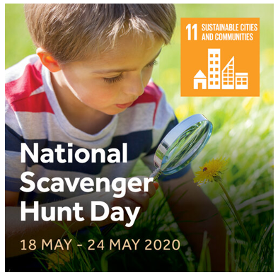
It’s Week 3 of the Great Science Share. This week’s theme is Nature Scavenger Hunts

National Scavenger Hunt Day is a day to enjoy the fun of a scavenger hunt. It’s time to look down, and look closely at the fascinating world around us. Hunt for habitats and living things in your spaces.
Share your questions about the habitats and living things all around us.
Things children may wonder about…
- How many shades of green can I see near me?
- Where can I find wildflowers?
- Which insects are in this habitat?

Visit the website at:
https://www.greatscienceshare.org/getinvolved2020#weekly-themes-2020-wk3

There’s lots of inspirational things to try:

- Sir David Attenborough recently celebrated his 90th birthday, there’s a short video featuring him showcasing the mind-blowing variety of life on Earth
- Wonder Wednesday Live lesson with @DrChips_ on 20th May 2020 at 10am.
- #AskAQuestion: Find out how Dr Eleanor Raffan became interested in variation between species.
- Dryads diary - Observe trees as they change throughout the year
- Go on a Wildflower Foray - Explore the variety of flowers growing around you
- Go on a Spider Safari in your home
- Leaf it Explore and enjoy measuring leaves
- Woodland Plant Survey identify the different plants growing in different places
- Edible Life Cycle Make a butterfly life cycle
Have fun asking questions and finding out more! We’d love you to share what you do on your class blog too.
Miss Simpson (Science coordinator)

